- BASIC ORGANIZATION OF A COMPUTER

A Computer is an information processing machine. It consists of a number of interrelated components that work together with the aim of converting data into information. Data is entered through input devices. This data is processed using the central processing unit and then the processed data is displayed to the users using various output devices. All these parts are known as hardware of the computer.
To perform operations, computers need to be given instructions. These instructions are known as programs, which constitute the software.
2.1. Components of Computer
Hardware refers to all visible devices that are assembled together to build a computer system. These include various input devices, central processing unit, output devices and memory.
2.1.1. Input devices: They are electromechanical devices that allow the user to feed information into the computer for analysis, storage and to give command to the CPU.
Computer accepts input in two ways. They are:
  - Manual entry: Here the information is entered using keyboard or mouse.
  - Direct entry: Here the information is fed into the computer automatically from a source document like barcode.
Examples for Input devices: Keyboard, Mouse, Joystick and Scanners.
- Central Processing Unit: It is referred as the brain of a computer system. It converts data (input) into meaningful information (output). It is a highly complex, extensive set of electronic circuitry which executes stored program instructions. It controls all internal and external devices. It performs arithmetic and logic operations. It controls the usage of main memory to store data. The main operations of the CPU include four phases:
  - fetching instructions from the memory
  - decoding the instructions
  - executing the instructions
  - storing the results back in the memory

It consists of three main subsystems. They are:
    - Arithmetic/Logic Unit (ALU)
    - Control Unit (CU)
    - Registers

Central Processing Unit
Registers
Input Unit
Output Unit

ALU
Control Unit

Instruction Flow
Data Flow

Fig. 2.1. Various Hardware Devices

2.1.2 Arithmetic Logic Unit (ALU): it contains the electronic circuitry that executes all arithmetic and logical operations on the data. ALU comprises of two units
Arithmetic Unit and Logic Unit.
- Arithmetic Unit: The arithmetic Unit contains the circuitry that is responsible for performing the arithmetic calculations. The arithmetic operations can be addition, subtraction, multiplication and division
- Logic Unit: It enables the CPU to perform logical operations based on the instructions provided. The various operations include greater than (>), less than (<), equal to(=), not equal to(!=),shift left, shift right, etc.it makes uses of various logical gates such as AND, OR, NOR, etc. for performing logical operations.
Control Unit: This unit checks the correctness of sequence of operations. It fetches the instructions from the memory, interprets them and ensures correct execution of the program.
Registers: Registers are special-purpose, high speed temporary memory units that hold various types of information such as data, instructions, addresses etc. The instructions are fetched, decoded and then executed in a proper sequence. To perform the task of fetching the instruction, computer uses program counter (PC) and instruction register (IR). The MAR (Memory Address Register) and MDR (Memory Data Register) are used to handle the data transfer between the main memory and the processor. Along with these registers processor has few general purpose registers which are used to hold the operands, the partial results and the memory addresses. Accumulated register (A) to hold the one operand for the arithmetic and logical unit
    - Memory: Memory refers to the electronic holding place for instructions and data. Memory also stores the intermediate results and output. Memory can be classified into two categories
- Primary Memory: It is also knows as main memory. It stores data and instructions for processing. It can be classified as random access memory (RAM) and Read only memory (ROM).
ROM is a read only memory. We cannot write data in this memory. It is non-volatile memory i.e it can hold data even if the power is turned off. ROM is used to store the binary codes for the sequence of instructions to carryout and data such as look up tables.
There are four types of ROM: Masked ROM, P ROM, EP ROM and EEP ROM.
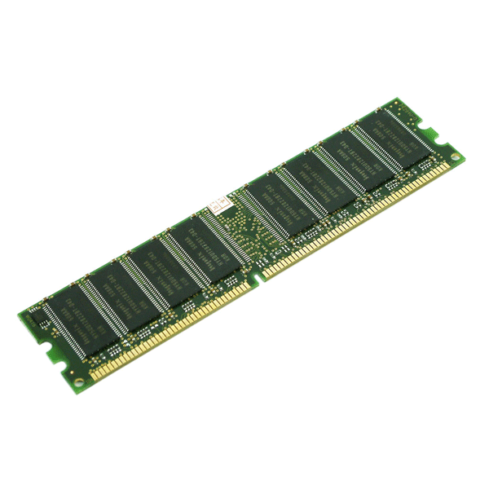
RAM is a random access memory. We can read from or write into the RAM. The numerical and character data that are to be processed by the computer change frequently.
Fig. 2.2 RAM

These data must be stored in this type of memory from which they can be read by the microprocessor and return back for storage. It cannot hold data when power is turned off.
There are two types of RAM: static RAM and dynamic RAM.
Cache memory: It is used to store the data and the related application that was last processed by the CPU. When the processor performs processing, it first searches the cache memory and then RAM, for an instruction. The cache memory is always placed between CPU and the main memory.
- Secondary Memory: It is also known as auxiliary memory or external memory. It is used for storing software programs and data. It is less expensive and stores huge volume of data. The secondary storage devices can be classified as: magnetic storage devices, optical storage devices and magneto optical storage devices.
Eg: hard disk, floppy disk, zip disk, CD ROM, write once read many, DVD, USB, etc.
2.1.4. Output Devices: Output Devices take the machine-coded output results from the CPU and convert them into a form that is easily readable by human beings. The output unit consists of output devices to display or print the results. The output devices can be classified as: hard copy devices and soft copy devices.
- Soft copy: The electric version of an output, which usually resides in computer memory and / or on the disk, is known as soft copy. The soft copy output also includes audio and visual form of output generated using computer.
- Hard copy: we obtain hard copy output for our images/text in several formats using printer or plotter. The quality of pictures obtained from a hard copy device depends on dot size and the number of dots per inch. Various types of printers are: ink jet printers, laser printers, dot matrix printers, etc.
- Inkjet Printers:
A type of printer that works by spraying ionized ink at a sheet of paper. Magnetized plates in the ink's path direct the ink onto the paper in the desired shapes. Ink-jet printers are capable of producing high quality print approaching that produced by laser printers. A typical ink-jet printer provides a resolution of 300 dots per inch, although some newer models offer higher resolutions.
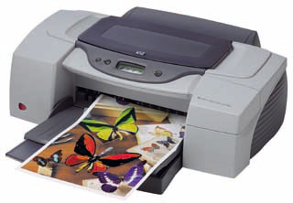

- Laser Printer
A type of printer that utilizes a laser beam to produce an image on a drum. The light of the laser alters the electrical charge on the drum wherever it hits. The drum is then rolled through a reservoir of toner, which is picked up by the charged portions of the drum. Finally, the toner is transferred to the paper through a combination of heat and pressure. This is also the way copy machines work.
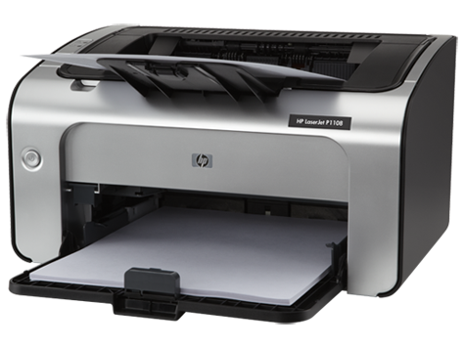
- Dot Matrix Printer
A type of printer that produces characters and illustrations by striking pins against an ink ribbon to print closely spaced dots in the appropriate shape. Dot-matrix printers are relatively expensive and do not produce high-quality output. However, they can print to multi-page forms (that is, carbon copies), something laser and ink-jet printers cannot do.
Dot-matrix printers vary in two important characteristics:
    - Speed: Given in characters per second (cps), the speed can vary from about 50 to over 500 cps. Most dot-matrix printers offer different speeds depending on the quality of print desired.
    - Print quality: Determined by the number of pins (the mechanisms that print the dots), it can vary from 9 to 24. The best dot-matrix printers (24 pins) can produce near letter-quality type, although you can still see a difference if you look closely.
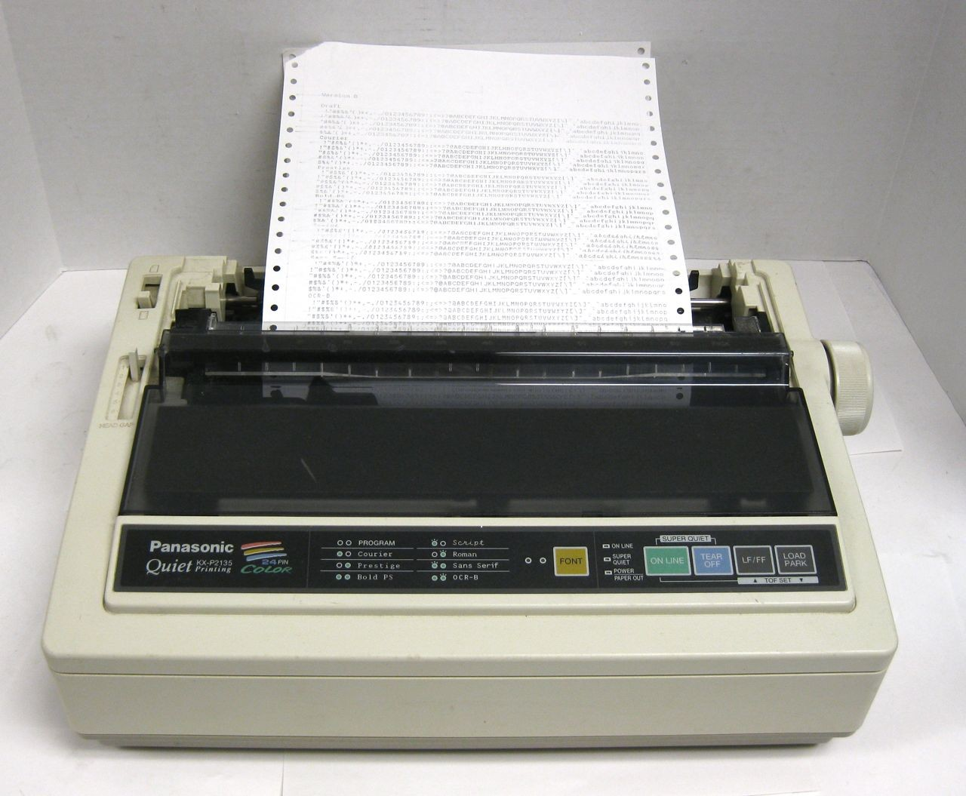

2.2 Software:
Software is nothing but the collection of data and instructions. It is responsible for controlling, integrating and managing the hardware components of a computer and to accomplish a specific task.

Software can be classified into two categories. They are: System Software and Application software.
    - System Software: It is a set of programs to help the user to run the computer systems. It is more transparent and less noticed by the user since they interact with the hardware or the applications. Some examples of system software are: operating systems, device drivers, language translators and system utilities.
  - Operating System: Operating System is the first layer of software loaded into main memory when it starts up. It acts as an interface between user and the hardware. Some of the functionalities of the operating system are: memory management, device management, CPU management etc.
  - Device Drivers: They are system software which is responsible for proper functioning of devices. Whenever a device is connected to the computer system, the driver software has to be installed so that the device can function properly. A driver acts as a translator between device and the operating system.
  - Language Translators: Computers can understand only binary language i.e. codes which consist of 0s and 1s. The users write instructions in high level language. The translators convert the high level instructions into machine code. There are 3 different types of language translators. They are:
    - Compiler: The compiler translates the source code (high level language code) into object code (Binary form).
    - Interpreter: An interpreter does the translation and executes the program line by line.
    - Assembler: It translates the program written in assembly level language into machine code.
- System Utility: System utility programs perform day-to-day tasks related to the maintenance of the computer system. They are used to support, enhance and secure existing programs and data in the computer system.
    - Application Software: This is the most used software by the users. It is used to accomplish specific tasks. Application software consists of a single program (Ex. Notepad) or a collection of programs (Ex. Microsoft Office Suite). Some of the most commonly used application software are:
- Word Processors: A word processor is software used to compose, format, edit and print electronic documents. Ex. Microsoft word.
- Spreadsheets: A spreadsheet application is a rectangular grid, which allows text, numbers and complex functions to be entered into a matrix of thousands of individual cells. Rx. Microsoft Excel.
- Image Editors: Image editor programs and designed specifically for capturing, creating, editing and manipulating images. The programs provide a variety of special features for creating and altering images. Ex. Adobe Photoshop.
- Database Management Systems: Database Management software is a collection of computer programs that allow storage, modification and extraction of information from a database in an efficient manner. It controls the security and integrity of the database from unauthorized access. Ex. Oracle.
- Presentation Applications: A Presentation is a means of assessment, which requires presentation providers to present their work orally in the presence of an audience. It combines both visual and verbal elements. Presentation software allows the user to create presentations by producing slides for the presentation of projects. Ex. Microsoft PowerPoint.
- Desktop Publishing Software: The desktop publishing is a technique of using a personal computer to design images and pages, and assemble type and graphics, then using a printer to output the assembled pages onto paper. This software is used for creating magazines, books etc. Ex. Adobe PageMaker.

